Software Quality Assurance (SQA) – 4th Week Project Task
Name: Dariya Hashmi -- DHC (2403)
Project Title: Performance & Load Testing Test Plan

Objective:
The objective of this performance test is to evaluate the login and logout functionality of The Internet demo site (https://the-internet.herokuapp.com) under multiple virtual users using JMeter. The test measures response time, throughput, and error rate, and verifies the system’s ability to handle concurrent users.

Test Environment:
- System: Windows 10, 8GB RAM, Intel i5
- JMeter Version: 5.6.3
- Browser: Chrome 146.0
- Website Tested: The Internet Demo Site

Load Test Scenario:
Parameter | Value
Number of Users | 5
Ramp-Up Period | 5 seconds
Loop Count | 1
Samplers | Login → Logout
Config Element | HTTP Cookie Manager
Listeners | View Results Tree, Graph Results, Summary Report

Observations / Results :
- Login Response: "You logged into a secure area!"
- Logout Response: "You logged out of the secure area!"
- Error Rate: 0%
- Average Response Time: ~1–2 seconds
- Throughput: Stable for 5 users

Screenshots:
Fig 1: View Results Tree – Login & Logout Responses

Fig 2: Summary Report – Performance Metrics
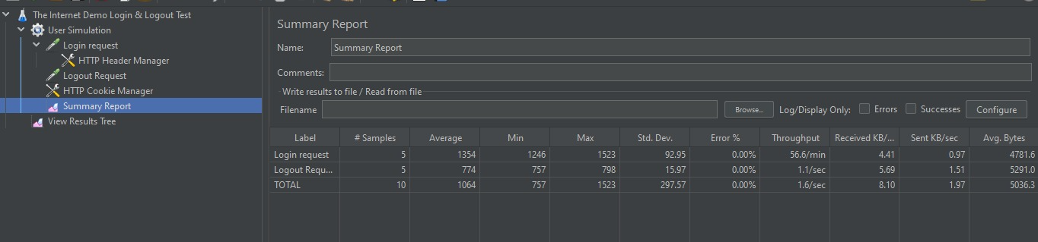
Fig 3: Graph Results – Response Time & Throughput
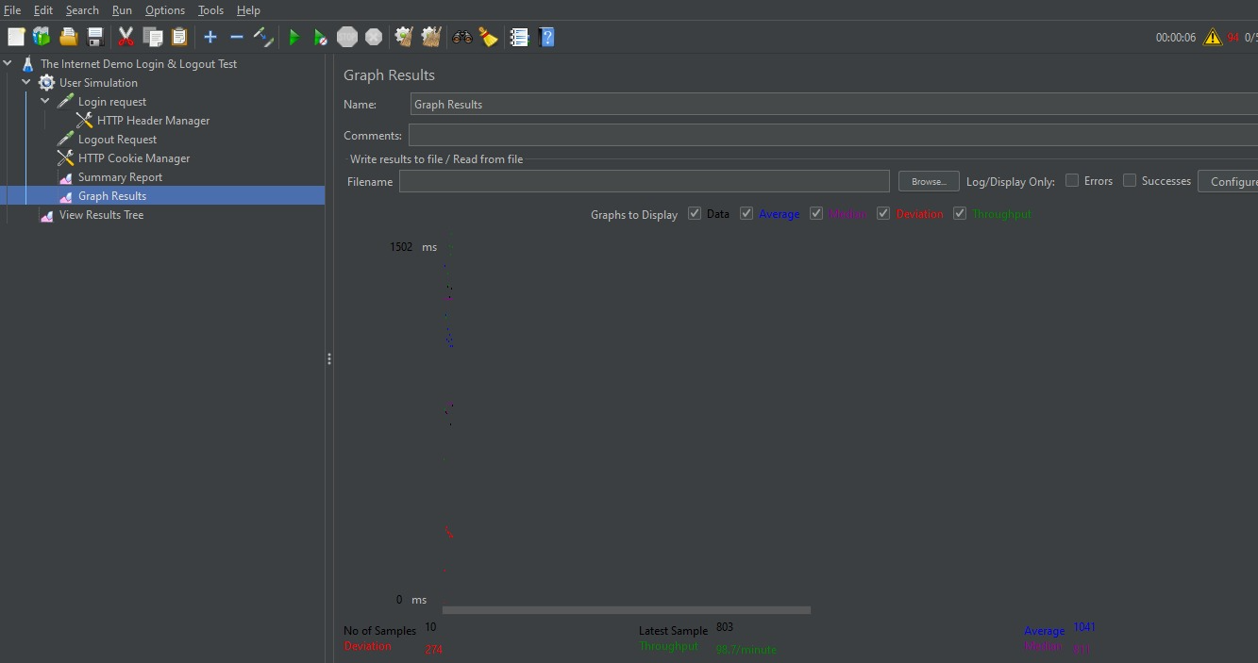

Conclusion & Recommendations:
- The Internet demo site successfully handled 5 concurrent users.
- Average response time remained under 2 seconds.
- No errors observed during the test.
- Recommendation: Gradually increase threads to 10–50 for higher load testing.
Github Repository :

